1. Read and translate the text.

Text 1. THE RUSSIAN FEDERATION

The Russian Federation is the largest country in the world. It occupies about one-seventh of the earth's surface. It covers the eastern part of Europe and the northern part of Asia. Its total area is about 17 million square kilometres. The country is washed by 12 seas of 3 oceans: the Pacific, the Arctic and the Atlantic. In the south Russia borders on China, Mongolia, Korea, Kazakhstan, Georgia and Azerbaijan. In the west it borders on Norway, Finland, the Baltic States, Belorussia, the Ukraine. It also has a sea-border with the USA.
There is hardly a country in the world where such a variety of scenery and vegetation can be found. We have steppes in the south, plains and forests in the midland, tundra and taiga in the north, highlands and deserts in the east.
There are two great plains in Russia: the Great Russian Plain and the West Siberian Lowland. There are several mountain chains on the territory of the country: the Urals, the Caucasus, the Altai and others. The largest mountain chain, the Urals, separates Europe from Asia.
There are over two million rivers in Russia. Europe's biggest river, the Volga, flows into the Caspian Sea. The main Siberian rivers - the Ob, the Yenisei and the Lena – flow from the south to the north. The Amur in the Far East flows into the Pacific Ocean.
Russia is rich in beautiful lakes. The world's deepest lake (1,600 metres) is Lake Baikal. It is much smaller than the Baltic Sea, but there is much more water in it than in the Baltic Sea. The water in the lake is so clear that if you look down you can count the stones on the bottom. Russia has one-sixth of the world's forests. They are concentrated in European north of the country, in Siberia and in the Far East.
On the vast territory of the country there are various types of climate, from arctic in the north to subtropical in the south. In the middle of the country the climate is temperate and continental. Russia is very rich in oil, coal iron ore, natural gas, copper, nickel and other mineral resources.
Russia is a parliamentary republic. The Head of State is the President. The legislative powers are exercised by the Duma. The capital of Rissia is Moscow. It is its largest political, scientific, cultural and industrial centre. It is one of the oldest Russian cities.
2. Learn geographical names and new vocabulary:

NAMES:

The Russian Federation - Российская Федерация;
Europe – Европа; European – европейский; Asia - Азия;
the Pacific Ocean - Тихий океан;
the Arctic Ocean - Северный Ледовитый океан;
the Atlantic Ocean -Атлантический океан;
China - Китай; Mongolia – Монголия; Korea – Корея;
Kazakhstan – Казахстан; Georgia – Грузия;
Azerbaijan – Азербайджан; Norway – Норвегия;
Finland – Финляндия.
The Baltic States - Прибалтийские государства;
the Baltic Sea – Балтийское Mope;
Far East - Дальний Восток;
Belorussia – Белоруссия; the Ukraine – Украина;
the Great Russian Plain – Русская (Восточно-Европейская) равнина;
the West Siberian Lowland – Западносибирская низменность;
the Urals – Уральские горы; the Caucasus -Кавказ;
the Altai – Алтай; the Volga - Волга;
the Caspian - Каспийское море;
the Ob - Обь; the Yenisei – Енисей; Amur – Амур;
Lake Baikal – озеро Байкал; Siberia – Сибирь.

VOCABULARY
to occupy – занимать
surface – поверхность
eastern – восточный
northern – северный
total area – общая площадь
square kilometre – квадратный километр
to wash – омывать
to border on – граничить с
sea-border – морская граница
There is hardly a country in the world… - Едва ли найдется страна...
variety – разнообразие, множество
scenery – пейзаж, ландшафт
vegetation – растительность
plain – равнина
midland – средняя полоса
tundra – тундра
taiga – тайга
highland - нагорье, высокогорная местность
mineral resources – полезные ископаемые
to decrease - снижаться, падать
constantly – постоянно
the rate of inflation - уровень инфляции
in spite of – несмотря на
the younger generation – молодое поколение
powerful - могучий
chain – цепь
to separate – разделять
to flow into – впадать
to count – считать
bottom – дно
to concentrate – сосредотачиваться, концентрироваться
vast – обширный
territory – территория
various – различный
climate – климат, климатический пояс
subtropical – субтропический
temperate – умеренный
oil, coal, iron – нефть, уголь, газ
copper – медь
parliamentary – парламентский
head of state – глава государства
legislative – законодательный
powers – полномочия
tо exercise – осуществлять, выполнять
scientific – научный
complicated – сложный, запутанный

3. Give the plural of nouns.
Country, part, sea, border, plain, mountain, river, lake, forest, stone, type, capital, centre, city, price, factory, plant, ocean, state.
4. Read and translate the numerals:
17 million square kilometres; by 12 seas; 3 oceans; 1/7 of the earth’s surface; over 2,000,000 rivers; 1,600 metres; 1/6 of the world’s forests.
5. Find degrees of comparison.
The largest country; Europe’s biggest rives; the world’s deepest lake; much smaller; much more water; the oldest Russian cities.
6. Define the words:
Surface, square, two, rich, clear, bottom, if, vast, they, parliamentary, legislative, scientific, because, younger, concentrate, generation.
7. Translate the international words:
Federation, occupy, total, republic, continental, mineral, climate, type, concentrate, territory, resources, industrial.
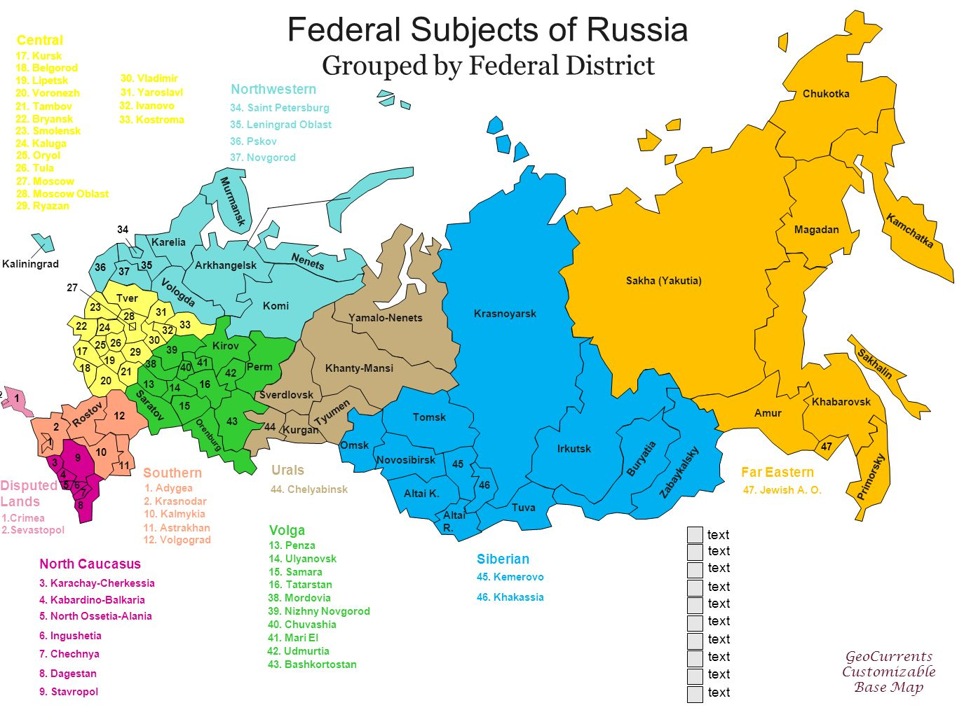8. Give the participles.
Separate, occupy, wash, look, have, count, exercise, decrease, lead, become, be.
9. Translate the expressions.
- Sea border – Russia borders on Finland
- mountain chain – the highest mountain
- the main Siberian rivers flow from the south – fast flow
- the head of state – to head the department

10. Complete the sentences:
- river, the, into, Volga, Europe’s, biggest, Caspian, the, flows, sea
- rich, is, beautiful, Russia, in lakes
- deepest, the, lake, Baikal, the, Lakes, world’s, is
- is, parliamentary, Russia, a, republic
- state, the, Head, President, the, of, is
- one, cities, Russian, is, oldest, of, it, the
- Russia, is, capital, the, Moscow, of

11. Answer the questions.

- Where is the Russian Federation situated?
- What is total area of the country?
- What countries does Russian border' on?
- What mountain chain separates Europe from Asia?
- How many rivers are there in Russia?
- Which is the longest river in Europe?
- What do you know about Lake Baikal?
- Do you know what strait separates Russian from America?
- What mineral resources is the Russian Federation rich in?
- What is the climate like in Russia?
- What can you say about the Russian economy?
- What great Russians do you know?

Text 2. Russia
Russia is one of the largest countries in the world. The vast territory of Russia lies in the eastern part of Europe and the northern part of Asia.
Russia is washed by twelve seas and three oceans. The oceans are: the Arctic, the Atlantic, the Pacific. The seas are: the White Sea, the Barents Sea, the Okhotsk Sea, the Black Sea, the Baltic Sea and others.
Russia borders on many countries, such as Mongolia and China in the south-east, Finland and Norway in the north-west, and so on.
The land of Russia varies very much from forests to deserts, from high mountains to deep valleys. The main mountain chains are the Urals, the Caucasus and the Altai. There are a lot of great rivers and deep lakes on its territory. The longest rivers are the Volga in Europe and the Ob, the Yenisei and the Lena in Asia/The largest lakes are Ladoga and Baikal. Baikal is the deepest lake in the world and its water is the purest on earth.
The Russian Federation is rich in natural and mineral resources. It has deposits of oil, gas, coal, iron, gold and many others.
The current population of Russia is more than 140 million people. The European part of the country is densely peopled, and most population live in cities and towns and their outskirts.
The capital of the Russian Federation is Moscow, with the| population of about 10 million people. Russia is a presidential republic.

Topical Vocabulary
vast territory - обширная территория
to lie - лежать, находиться
to border on - граничить
a desert - пустыня
mountain chain - горная цепь
pure - чистый
to be rich in - быть богатым
natural and mineral resources — ресурсы и полезные ископаемые
a deposit of smth. - месторождение
oil - нефть
gas - газ
coal - уголь
iron - железо
gold - золото
the current population - население в настоящий момент
to be densely peopled- быть густонаселенным
a presidential republic-президентская республика
a power - держава

Text 3. Moscow
Moscow is one of the largest cities in the world and this is the capital of Russia. It is a political, industrial, cultural, educational, sports and scientific center of our country. The population of Moscow is more than 10 million people. It is situated in the western part of the country, on the Moskva river. The city was founded by Prince Yuri Dolgorukiy and it was first mentioned in the chronicles in 1147.
About five million foreign tourists visit Moscow every year. Red Square and the Kremlin are in the heart of Moscow. Russian president and the government work here. So these are the first places of interest for tourists from all over the world. And the main clock of the Spasskaya Tower in Red Square is the icon of our capital. You can also find a unique architectural wonder - St. Basil’s Cathedral and the oldest monument to the liberators Minin and Pozharsky. Visitors of the Kremlin can see the Tzar-Cannon and the Tzar-Bell on its territory. The magnificent Cathedral of Christ the Saviour is another symbol of Moscow. This is the tallest Orthodox church in the world which is situated on the bank of the Moskva river.
Moscow is proud of its countless museums and galleries: the History Museum, the Armoury Chamber, the Diamond Fund, the Space Museum. Art lovers usually visit the outstanding Tretyakov State Gallery, the Pushkin Museum of Fine Arts and the Andrei Rublev Museum. A fabulous collection of paintings, icons and sculptures is exhibited there.
There are also a lot of drama theatres and opera houses in Moscow which are worth visiting. The Bolshoi and the Maliy Theatres are world-famous, of course, but there are about 70 other professional theatres in Moscow.
There are many prestigious high schools in the city which provide a perfect level of education. Lomonosov Moscow State University is probably the most famous and it offers a wide range of modern occupations.
Moscow is very noisy and crowded. There are thousands of cars, buses, trams and trolley-buses moving along its wide streets. Moscow Metro is famous for its beautiful interior and convenience. Today it has about 200 underground stations and the total length of underground lines here is more than 200 kilometres.
A business district Moscow City is a modern architectural masterpiece to admire. A lot of amazing glass-fronted skyscrapers have been built there.
Moscow is the capital of our Motherland and that is why we are very proud of it. It is dear to the heart of every Russian citizen.

- What is the population of Moscow?
- Where is Moscow situated in the country?
- Who has founded Moscow?
- How many foreign tourists visit Moscow every year?
- What are the main attractions for tourists in Moscow?
- What is the significance of the Spasskaya Tower in Red Square?
- What are some other famous monuments or landmarks in Moscow?
- What are some of the museums and galleries in Moscow?
- What are some famous theatres in Moscow?
- What is the significance of Lomonosov Moscow State University?
Text 4. Political System of Russian Federation
Russia is a federal semi-presidential state. It has a republican form of government and a centralized political system. The power is divided among the legislative, executive and judicial branches.
The executive power is concentrated in the President and the Prime Minister, although the President is dominant as the head of the state. The President of Russia is elected by the people for a term of 6 years for a maximum of two consecutive terms. The President is the chairman of his consultative bodies: the State Council and the Security Council and is the commander-in-chief of the armed forces. The President determines basic domestic and foreign policies of the Russian Federation and he can veto draft bills. He is also vested with power to dismiss the government.
The Prime Minister is appointed as the head of the government by the President, with the State Duma’s approval. Government duties are distributed between several ministries. The government ensures realization of domestic and foreign policies, works out the federal budget, provides the principles of law, human rights and freedoms.
The legislature in Russia is represented by the bicameral Federal Assembly. It consists of the State Duma (the lower house) and the Federation Council (the upper house). The Federal Assembly makes federal law, approves treaties and declares war. All bills must be first considered by the State Duma. Once a bill has been passed by a majority of the Duma, it is sent back to the Federation Council. The Federation Council has such special powers as declaration of presidential elections, the President’s impeachment and decisions on the use of the armed forces outside Russia’s territory.
The judicial power in Russia is exercised by the courts and administered by the Ministry of Justice. The Supreme Court of Russia is at the highest level. The judges of the Constitutional Court, the Supreme Court and the High Arbitration Court are appointed by the Federation Council.
The Russian political system is multiparty. The party with its majority in the parliament can form the Russian government.
Crossword 1. “Russia”
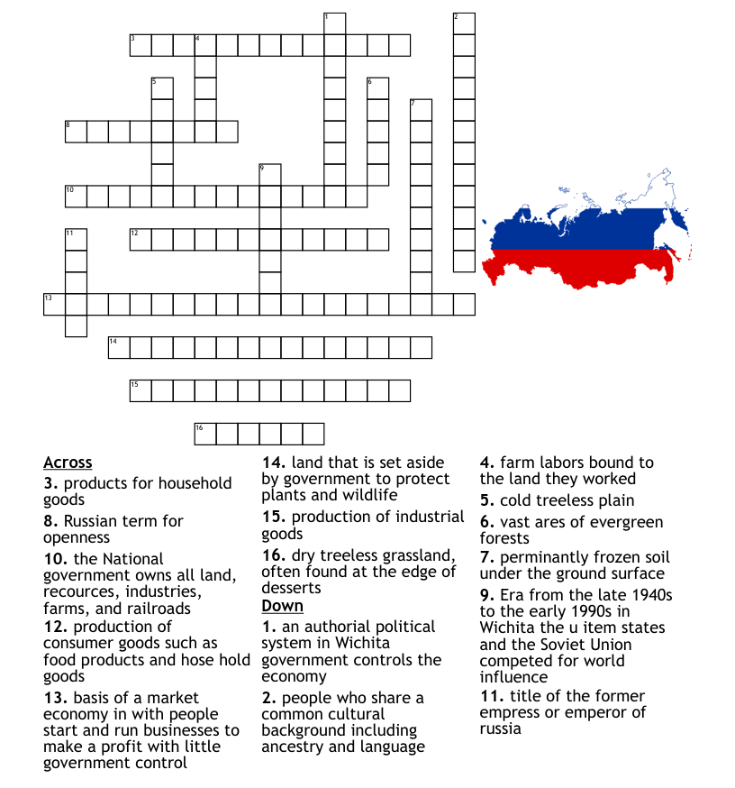

Crossword 2. “Russia”
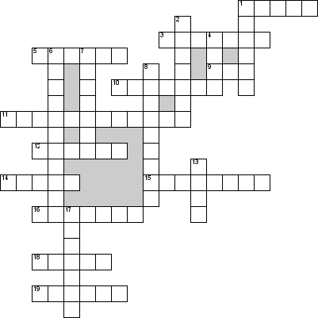

По горизонтали:
1. What tree is the symbol of Russia
3. What is the name of the continent where Russia is located
5. The highest mountain in Russia
9. What country has sea-border with Russia
10. Each chamber is headed by …
11. What is the name of the main law of the Russian Federation
12. The national symbol of the Russian Federation is white-blue-red …
14. President of Russia
15. Federal … consist of two chambers
16. The first President of Russia
18. The national symbol of the Russian Federation is double-headed …
19. Capital of Russia
По вертикали:
1. The dippest lake in Russia
2. The most popular poet in Russia
4. One of the longest rivers in Asia
6. The … power belongs to the Federal Assembly
7. National language in Russia
8. Old name of St Petersburg
13. The national animal in Russia
17. The Russian Federation is the … country in the world

