Great Britain
The United Kingdom of Great Britain and Northern Ireland (the UK) is the official name of the British Kingdom. It occupies most of the territory of the British Isles and consists of four countries. They are England, Scotland, Wales and Northern Ireland. Their capitals are London, Edinburgh, Cardiff and Belfast.
The UK is situated off the west coast of Europe, between the Atlantis Ocean on the northwest and the North Sea on the east. It is separated from the European continent by the English Channel. The narrowest part of the English Channel is called the Strait of Dover. The total area of Great Britain is over 244,000 square kilometres.
The UK is an island state: it is made up of two large islands and several much smaller ones. The two main islands are Great Britain to the east and Ireland to the west. They are separated by the Irish Sea. Geographically, the island of Great Britain is subdivided into two main regions – Lowland Britain and Highland Britain. Lowland Britain comprises southern and eastern England. Highland Britain consists of Scotland, most of Wales, the Pennines, and the Lake District. Mountains are not very high. The highest mountain is Ben Nevis in Scotland (1,343m). England is separated from Scotland by the Cheviot Hills, running from east to west.
There are a lot of rivers in Great Britain, but they are not very long. The Severn is the longest river, while the Thames is the deepest and the most important one. The chief river in Scotland is the Clyde. Great Britain has many beautiful lakes. The best known of them is long narrow Loch Ness, legendary home of the famous monster. On the northwest side of the Pennine system lies the Lake District, containing beautiful lakes.
The largest cities of Great Britain are London, Birmingham, Liverpool, Manchester, Sheffield, Leeds, Edinburgh, Glasgow, Cardiff and Belfast.
The population of the United Kingdom is over 57 million people. English is the official language. But some people speak Gaelic in western Scotland, and Welsh, in parts of northern and central Wales.
The different parts of Britain have their own emblems. The red rose is the national emblem of England. The thistle is the national emblem of Scotland. The daffodils and the leek are the emblems of Wales. And the shamrock is the national emblem of Ireland.
The flag of the United Kingdom is known as the Union Jack. It is made up of three crosses: the cross of St. George (the patron saint of England), the cross of St. Andrew (the patron saint of Scotland) and the cross of St. Patrick (the patron saint of Ireland).
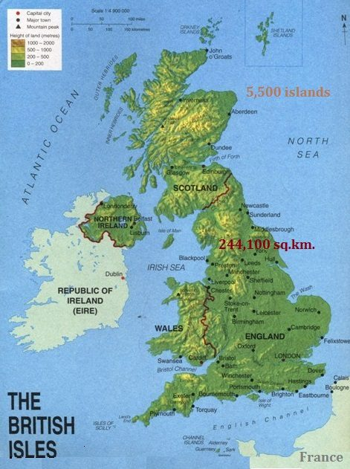
Выполни задания по тексту:
- Ответь на вопросы:
1) What is the official name of the British Kingdom?
2) What countries does Great Britain consist of and what are their capitals?
3) Why is the UK called an island state?
4) Where is the UK situated? What separates Great Britain from the continent?
5) What are the names of two main islands of the British Isles? What sea separates them?
6) What do we call the narrowest part of the English Channel?
7) What is the total area of Great Britain?
8) Into which two main regions is the island of Great Britain geographically subdivided?
9) What areas does Lowland Britain comprise?
10) What does Highland Britain consist of?
11) What is the highest mountain in the UK, and where is it situated?
12) Which is the longest river in Great Britain?
13) Which river is the deepest and the most important one?
14) What is the chief river in Scotland?
15) What is the famous lake in Scotland known for its legendary monster?
16) Where is the Lake District located?
17) What is the official language of the UK?
18) What is the population of the United Kingdom?
19) Which other languages are spoken in some parts of Scotland and Wales?
20) Can you name some of the largest cities in Great Britain?
21) What are the national emblems of the four countries of the UK?
22) What is the name of the UK flag?
23) What three crosses is the Union Jack made up of, and whom do they represent?

- Соедини слово из текста с его определением.

1. official A) a national or regional symbol
2. to be separated B) the number of people living in a place
3. emblem C) formal and accepted
4. population D) to be divided by a barrier
5. to be situated E) to be located in a particular place
Ответы: 1-C, 2-D, 3-A, 4-B, 5-E

- Раскрой скобки, поставив глагол в правильную форму Present Simple. Помни о согласовании с подлежащим (he/she/it → V+s).
1. The UK **(to consist)** of four countries.
2. The Severn **(to be)** the longest river in Great Britain.
3. Some people in Scotland **(to speak)** Gaelic.
4. The two main islands **(to be separated)** by the Irish Sea.
5. The total area of the UK **(to be)** over 244,000 square kilometres.
Ответы: 1. consists, 2. is, 3. speak, 4. are separated, 5. is

- Задай вопрос к выделенному слову (вопрос к подлежащему). Помни, что в таких вопросах порядок слов, как в утверждении, и не нужен вспомогательный глагол. Образец: The Thames is the deepest river. — What is the deepest river?
1. The English Channel separates the UK from the continent.
2. Ben Nevis is the highest mountain in the UK.
3. The red rose is the national emblem of England.
4. The Union Jack is the flag of the United Kingdom.
5. Fifty-seven million people live in the United Kingdom.
Ответы: 1. What separates the UK from the continent? 2. What is the highest mountain in the UK? 3. What is the national emblem of England? 4. What is the flag of the United Kingdom? 5. How many people live in the United Kingdom?

- Сопоставь страну и ее национальный символ.
Страна (Country) Символ (Emblem)
1. England A. The Thistle
2. Scotland B. The Shamrock
3. Wales C. The Red Rose
4. Ireland D. The Daffodil and the Leek
Ответы: 1-C, 2-A, 3-D, 4-B

- Выбери правильный предлог.
1. The UK is situated on / off / at the west coast of Europe.
2. It is separated from Europe by / with / from the English Channel.
3. The Lake District lies on / in / at the northwest side of the Pennine system.
4. The flag is made up of / from / by three crosses.
5. Many people live on / in / at large cities like London and Birmingham.
Ответы: 1. off, 2. by, 3. on, 4. of, 5. in

- Прочитай утверждения и отметь их как True (Верно), False (Неверно) или NS (Not Stated - В тексте не сказано).
1. The capital of Scotland is Glasgow.
2. The Thames is longer than the Severn.
3. Loch Ness is in Scotland.
4. The weather in the UK is very sunny.
5. The crosses on the Union Jack represent the patron saints of England, Scotland, and Ireland.
Ответы: 1. False (Edinburgh), 2. False (The Severn is the longest), 3. True, 4. NS, 5. True
- Закончи предложения, используя информацию из текста.
1. The United Kingdom is an island state because...
2. The Cheviot Hills are important because they...
3. Although there are many rivers in Great Britain,...
4. English is the official language, but...
Примерные ответы:
1. ... it is made up of two large islands and several smaller ones.
2. ... separate England from Scotland.
3. ... they are not very long.
4. ... some people also speak Gaelic and Welsh.

- В каждом предложении есть одна грамматическая ошибка. Найди и исправь её.
1. The UK are situated off the west coast of Europe.
2. The Severn are the longest river in Great Britain.
3. The flag of the UK known as the Union Jack.
4. Some people speaks Gaelic in western Scotland.
5. The thistle are the national emblem of Scotland.
Ответы: 1. are → is, 2. are → is, 3. known → is known, 4. speaks → speak, 5. are → is

- Разгадай кроссворд, используя текст.
По горизонтали:
2. Самая высокая гора в Великобритании.
5. Море, отделяющее Великобританию от Ирландии.
6. Официальное название британского королевства.
8. Столица Уэльса.
По вертикали:
1. Легендарное озеро в Шотландии.
3. Самый важный и глубокий река в Англии.
4. Пролив, отделяющий Великобританию от континента.
7. Столица Северной Ирландии.
Ответы:
По горизонтали: 2. Ben Nevis, 5. Irish, 6. United Kingdom, 8. Cardiff
По вертикали: 1. Loch Ness, 3. Thames, 4. Dover, 7. Belfast

- Выбери правильный вариант для завершения предложения.
1. The UK (occupies / occupy) most of the territory of the British Isles.
2. There (is / are) a lot of rivers in Great Britain.
3. The red rose (is / are) the national emblem of England.
4. The UK (is made / are made) up of two large islands.
5. Mountains in Great Britain (is / are) not very high.
Ответы: 1. occupies, 2. are, 3. is, 4. is made, 5. are

- Составь слова из букв, чтобы получились географические названия из текста.
1. N E S V E I (самая высокая гора)
2. N E H T A M (самая важная река)
3. T H I L S E T (символ Шотландии)
4. D R A F C I F (столица Уэльса)
5. V E R N E S (самая длинная река)
Ответы: Ben Nevis Thames Thistle Cardiff Severn

- Составь правильные предложения из слов. Обрати внимание на порядок слов и форму глаголов.
1. consists / four / the UK / countries / of
2. is / the UK / Europe / off / situated / the west coast of
3. the most / the Thames / important / is / river
4. are / the largest / London / cities / and Birmingham
5. the Union Jack / three / is / of / made up / crosses
Ответы:
1. The UK consists of four countries.
2. The UK is situated off the west coast of Europe.
3. The Thames is the most important river.
4. The largest cities are London and Birmingham.
5. The Union Jack is made up of three crosses.

- Сопоставь столицу со страной.
Столица Страна
1. Edinburgh A. Northern Ireland
2. London B. Wales
3. Belfast C. England
4. Cardiff D. Scotland
Ответы: 1-D, 2-C, 3-A, 4-B

- Напиши общий вопрос (требующий ответа Yes/No) к данным утверждениям. Образец: The UK is an island state. → Is the UK an island state?
1. The UK consists of four countries.
2. The Thames is the deepest river.
3. Some people speak Welsh in Wales.
4. The Lake District has beautiful lakes.
5. The Union Jack is made up of three crosses.
Ответы:
1. Does the UK consist of four countries?
2. Is the Thames the deepest river?
3. Do some people speak Welsh in Wales?
4. Does the Lake District have beautiful lakes?
5. Is the Union Jack made up of three crosses?

- Вставь подходящие по смыслу слова separated / flag / occupies / patron saint / population в предложения.
1. The UK __________ most of the territory of the British Isles.
2. Great Britain is __________ from the European continent by the English Channel.
3. The __________ of the United Kingdom is over 57 million people
4. St. George is the __________ of England.
5. The __________ of the UK is called the Union Jack.
Ответы: 1. occupies, 2. separated, 3. population, 4. patron saint, 5. flag

- Составь краткий пересказ текста.

- Перескажи текст на английском языке, показывая на карте упоминаемые географические названия.

- Подготовь чтение текста с правильным произношением.
Great Britain
The United Kingdom of Great Britain and Northern Ireland (the UK) is the official name of the British Kingdom. It consists of four countries: England, Scotland, Wales and Northern Ireland. Their capitals are London, Edinburgh, Cardiff and Belfast.
The UK is situated off the west coast of Europe, between the Atlantis Ocean and the North Sea. The total area of Great Britain is over 244,000 square kilometers.
The UK is made up of two large islands (Great Britain and Ireland) and several small islands. There are a lot of rivers in Great Britain: Severn, Thames, Clyde. Great Britain has many beautiful lakes. The largest cities of Great Britain are London, Birmingham, Liverpool, Manchester, Sheffield, Leeds, Edinburgh, Glasgow, Cardiff and Belfast.
The population of the United Kingdom is over 57 million people. English is the official language. The flag of the United Kingdom is known as the Union Jack. It is made up of three crosses: the cross of St. George, St. Andrew and St. Patrick.
- Назови по-английски и по-русски изображенные на картинках достопримечательности.

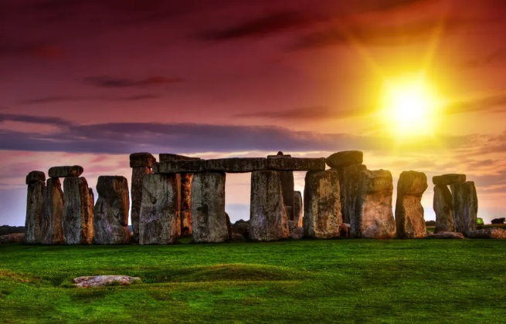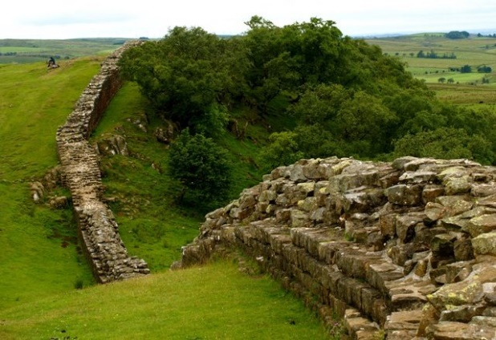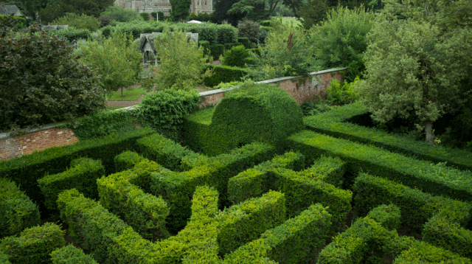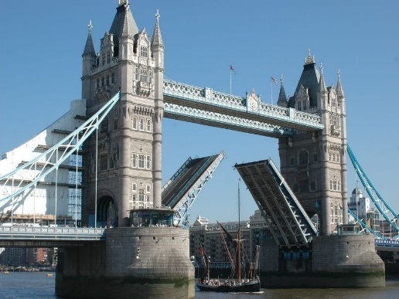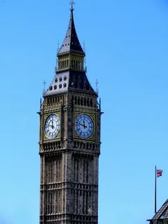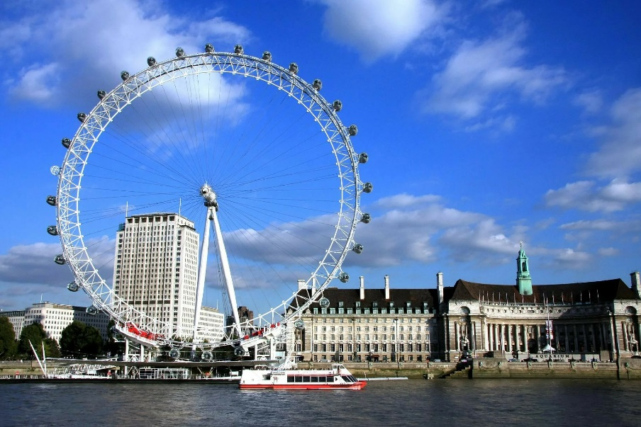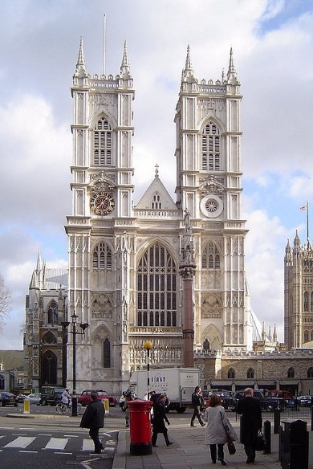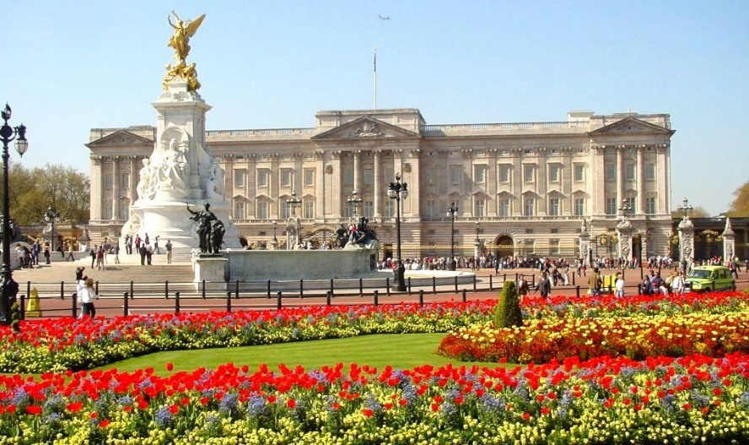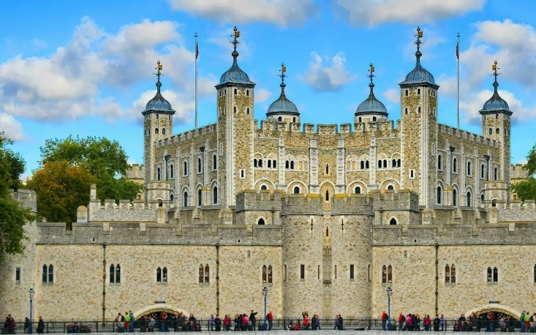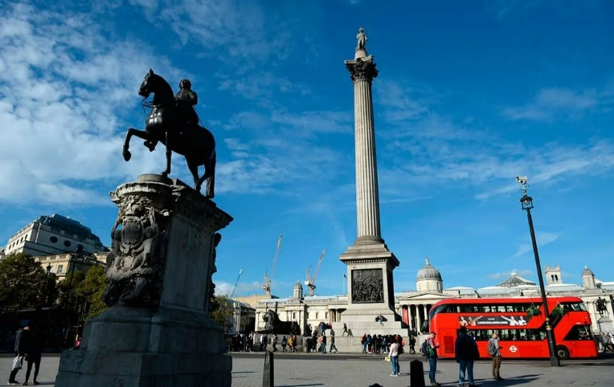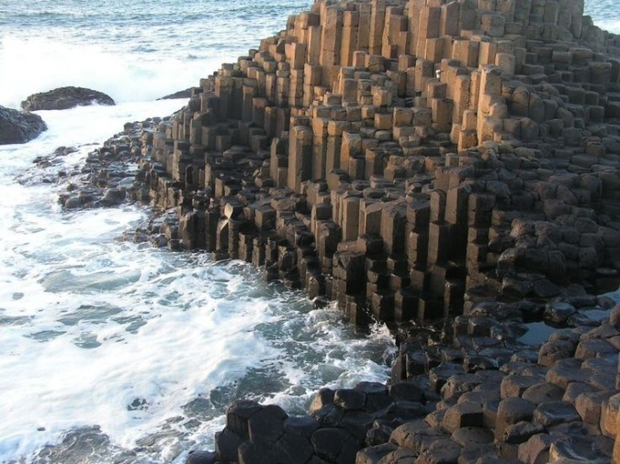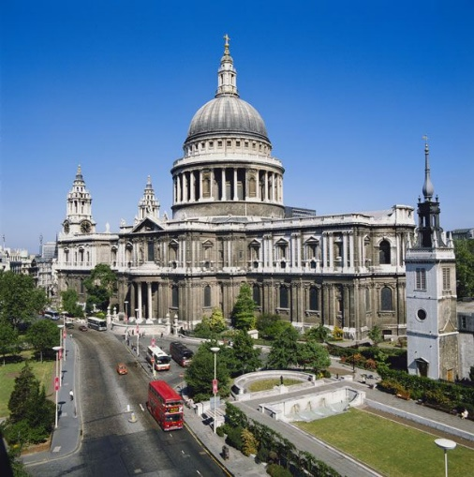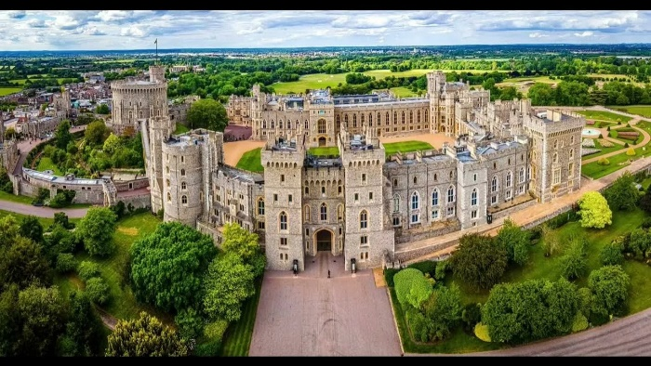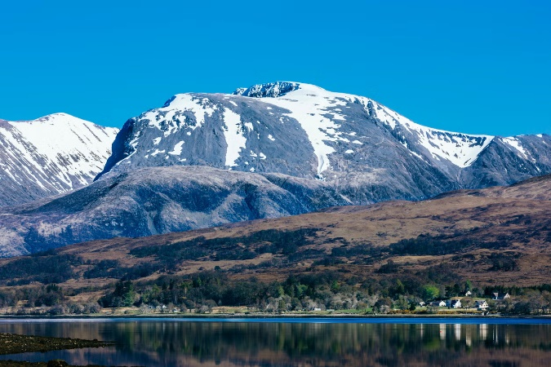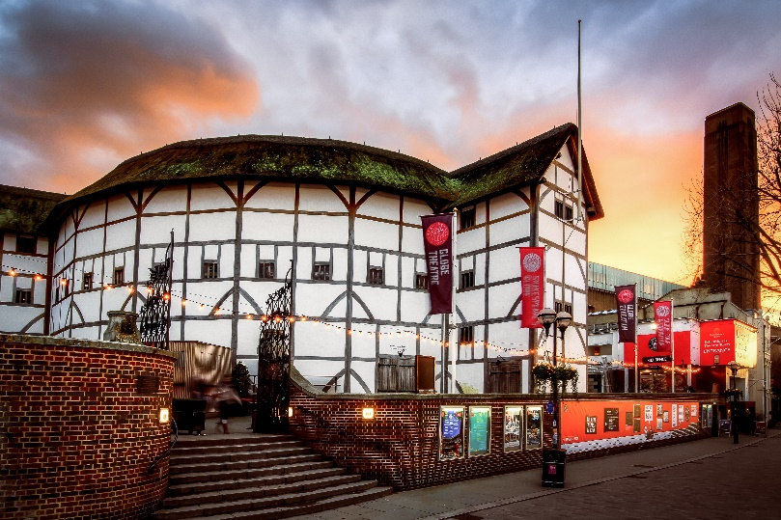

Giant’s Causeway
Westminster Abbey — готическая церковь, традиционное место коронации и захоронения британских королей и королев.
St Paul's Cathedral — собор, расположенный в самой высокой точке Лондона, на холме Ludgate Hill.
Stonehenge — известный доисторический памятник, находится в Уилтшире, Англия.
Windsor Castle — резиденция Британской монархии, крупнейший жилой замок в мире.
Ben Nevis — гора в Шотландском нагорье, самая высокая гора на Британских островах, её высота — 1344 метра.
The Globe Theatre — театр под открытым небом, современный театр был открыт в 1997 году и представляет собой копию старого театра.
Tower of London — крепость, в которой находятся Королевские драгоценности, одна из основных туристических достопримечательностей Великобритании.
London Eye — гигантское колесо обозрения, с которого открываются панорамные виды на Лондон.

- Разгадай кроссворды:

